# Doxygen:

Doxygen is a documentation generator that works with many programming languages. It extracts information from specially-formatted source code comments and saves the information in one of various supported formats. Doxygen supports static analysis of a codebase.

# Automotive DC motor drivers (used for driving electronic throttle bodies)

Driving DC motors using discrete circuits is a bad idea because of its complexity. As an example, a simple H-bridge with no protection circuitry requires four power transistors and a lot of gate drive circuitry while still not being able to provide any protection against over-current, over-temperature conditions.

Research indicates that ICs which include all of the mentioned functionalities exist. Take MC33186 as an example. A fully integrated and high-power DC motor driver.



The datasheet also provides typical usage figures.

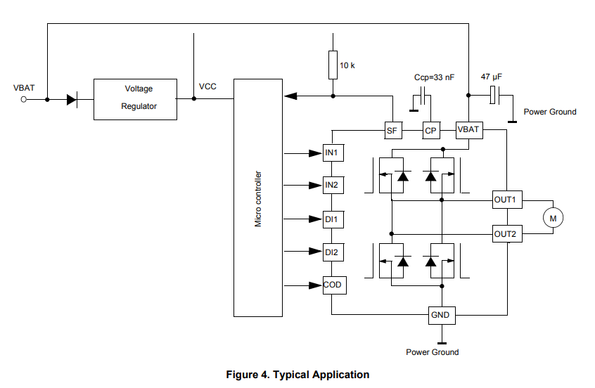

# Linked lists in programming

# Measuring thermistor temp sensor

## What is a thermistor?

A thermistor is a semiconductor type of resistor in which the resistance is strongly dependent on temperature. The varying resistance with temperature allows these devices to be used as temperature sensors, or to control current as a function of temperature.

The most common type of thermistor used in engines is a thermistor water temperature sensor shown below:

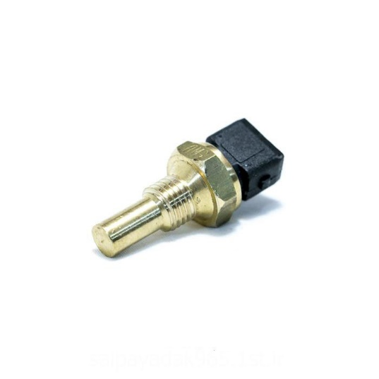This sensor is responsible for measuring the temperature of the engine coolant temperature and it helps the ecu decide how much fuel and ignition timing is should use to achieve optimal performance in different climate conditions.

## Steinhart–Hart equation

This equation shows the relationship between the resistance and temperature of the thermistor.

$$\frac{1}{T}=a+bLnR+c{\left(LnR\right)}^{3}$$

where a, b and c are called the Steinhart–Hart parameters and must be specified for each device. T is the absolute temperature, and R is the resistance.

However, there is a problem! We need to find the Steinhart-Hart equation parameters.

There is a good resource on the web that describes this in detail: [https://www.thinksrs.com/downloads/PDFs/ApplicationNotes/LDC%20Note%204%20NTC%20Calculatorold.pdf](https://www.thinksrs.com/downloads/PDFs/ApplicationNotes/LDC%20Note%204%20NTC%20Calculatorold.pdf%20)

A code needed to be developed first to measure resistances and then a code was developed to translate that measured resistance into a correct temperature reading.

Relative files: ‘thermistor.h’ and ‘resistor.h’

# Tuning for the end user

The end use is most certainly not advanced in c language skills, which means that there is a need to provide an easy-to-use interface for the user to be able to adjust parameters and settings in the SGC.

However, developing a windows or Linux application form scratch that can connect to the SGC would require a lot of effort and the end result would certainly not be pleasing to the eye or good to use.

Considering the above, I have decided to use Tuner Studio, which is an open-source software developed for open-source engine control units. Considering that it is used by a few successful projects that have been put into production, I can be assured that the end result will at least be pretty to look at and easy to use.

The down side is that I will need to learn how to code the configuration required for the software, meaning that I will have to make tuner studio and my controller speak the same language. This is most certainly going to be very challenging but I’m going to put in the effort.

Tuner Studio coding guide: <https://www.efianalytics.com/TunerStudio/docs/EFI%20Analytics%20ECU%20Definition%20files.pdf>

This is how Tuner Studio looks like:

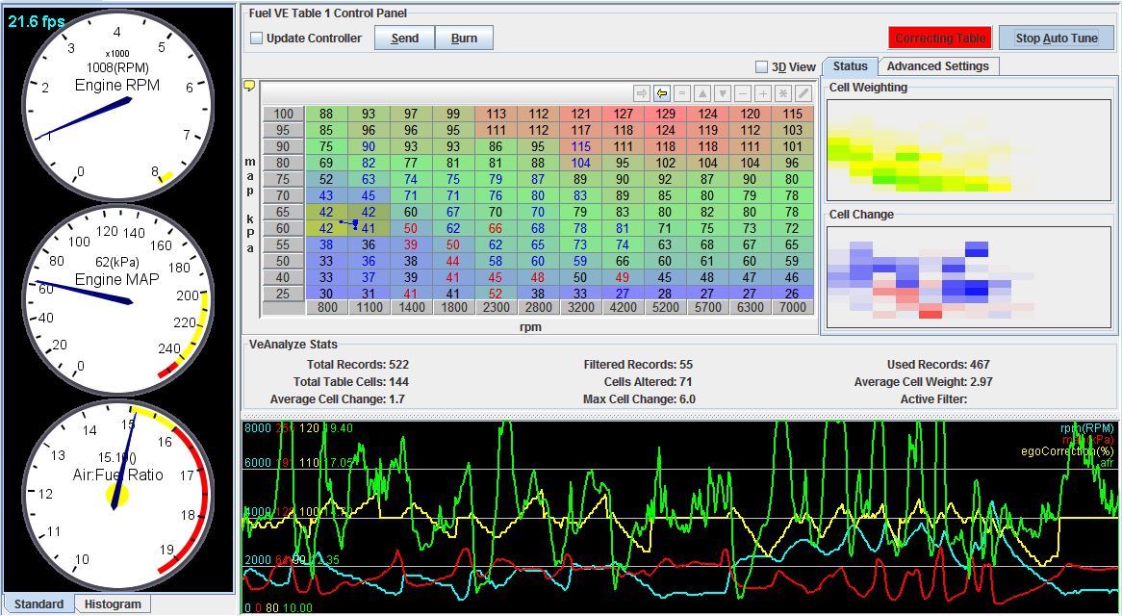

# Storing user configuration

Storing user configuration on the SGC requires a non-volatile memory which keeps user data even after the power is cut off. There are multiple approaches to this problem, including, using a micro-controller using a built-in EEPROM which stands for electrically erasable read only memory, using an external EEPROM IC or as I just found out, EEPROM emulation.

EEPROM emulation allows us to not have an external EEPROM chip which adds extra cost and complexity to the controller. By erasing sectors of flash memory in the microcontroller and carefully writing data on those sectors. We can store anything we want, effectively.

A software driver has been written by engineers at ST, using it seems relatively easy and there is a good resource on this matter on the ST’s website, AN3969.

# Calculating the amount of fuel that needs to enter the engine

The ratio of air to fuel varies depending on the fuel type and also the requirements of the engine. More on this later. The table below shows the stochiometric ratio of air to fuel for different types of fuel.

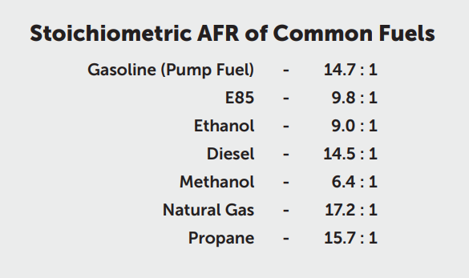 The stoichiometric air fuel ratio is the ratio of air to fuel that can enter the engine and burn completely in an idea situation.

The air fuel ratio has a major impact of the combustion process of the engine and specially it’s fuel economy.

Generally, a higher air to fuel ratio will result in more fuel economy but this does not mean that we can run any engine with a high air to fuel ratio. The reason being that combustion temperatures tend to rise as we increase the air fuel ratio and approach stoichiometric condition. This also results in an increase in the NOx emissions of the engine.

The table below illustrates this phenomenon:

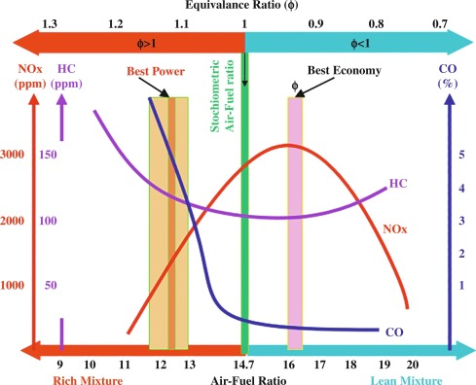

It is important to note that the catalytic converter in cars easily gets rid of most NOx emissions, this allows automotive manufactures to run their engines at high air to fuel ratios, providing more fuel economy for the final user but, the situation is different for generator engines as they usually do not have catalytic converters. Moreover, in case of backup generators, fuel economy is usually less of a concern.

My research and experience also indicate that running an engine closer to stoichiometric ratio is possible only in low-load conditions, where the engine is not under much stress and does not produce much heat. This is because leaner air to fuel mixtures – i.e. higher air to fuel ratios – result in more combustion temperatures which could risk damaging the engine components such as pistons and valves. 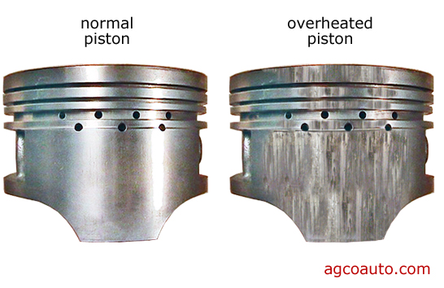

This means that we usually have to operate the engine using a rich air fuel mixture when it is under significant load. In order to adapt to these varying conditions, engine management systems use a table that dictates how much fuel should enter the engine.

This process is not as simple as it seems because every engine is different and the amount of air mass entering the engine varies widely with rpm, air pressure, throttle opening, and temperature.

In order to model the capacity of an engine to ingest air, we use a table known as volumetric efficiency (VE) table which describes how much air enters the engine vs how much air could theoretically enter the engine. This is expressed as a percentage and it is often less than 100%.

Knowing the VE of the engine at any point and intake air temperature, intake air pressure and rpm allows us to calculate the amount of air mass entering the engine, this then enables us to calculate the required amount of fuel that needs to be mixed with this air to have the correct air fuel ratio.

Further corrections can be applied to the amount of fuel to account for different operating conditions.

